**CLOUD KITCHEN MANAGEMENT SYSTEM**

**1.Description:** A cloud kitchen is a delivery-only restaurant that has no physical space for dine-in. It relies entirely on online orders placed through online food aggregators or an online ordering enabled website or mobile app. Introducing cloud kitchens, commercial facilities purpose-built to produce food specifically for delivery. These commissary kitchens are sometimes also known as **ghost kitchens, shared kitchens, or virtual kitchens** with the delivery-only food brands operating within them called virtual restaurants.

**The Database contains 7 tables:**

1)Breakfast_menu

2)Starter_menu

3)Maincourse_menu

4)Dessert

5)Order

6)Payment Details

7)Customers

How this tables/entities are related to each other is shown pictorially on next page ER diagram, i.e., Entity Relationship Diagram.

2. **ER- Diagram for Cloud Kitchen Management System:**

**CLOUD KITCHEN MANAGEMENT SYSTEM Database with MYSQL :**

* How to create Database for Cloud Kitchen?
* Query to CREATE DATABASE: create database Cloud_Kitchen;

use Cloud_Kitchen;

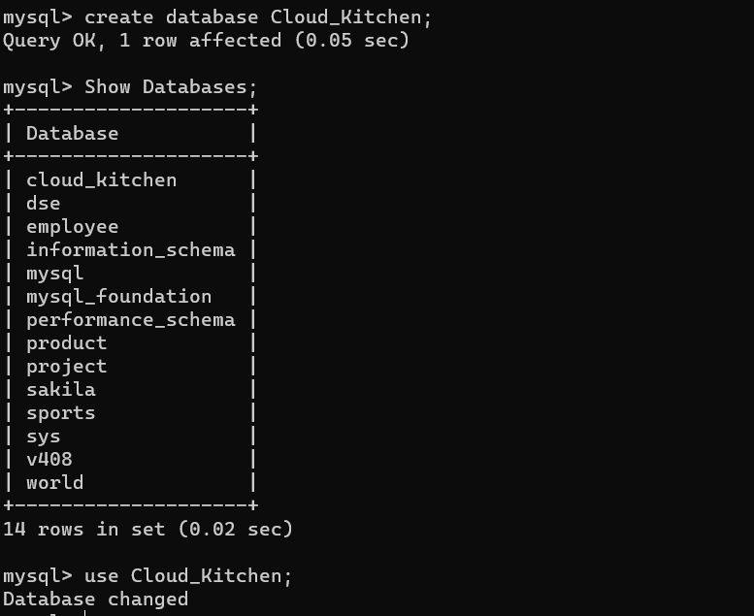

CLOUD KITCHEN TABLE STRUCTURES

* Breakfast_Menu :

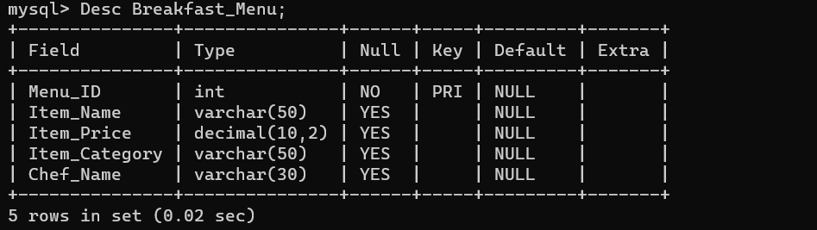

* Starter_Menu :

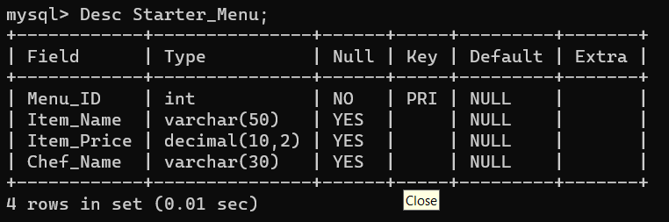

* MainCourse_Menu :

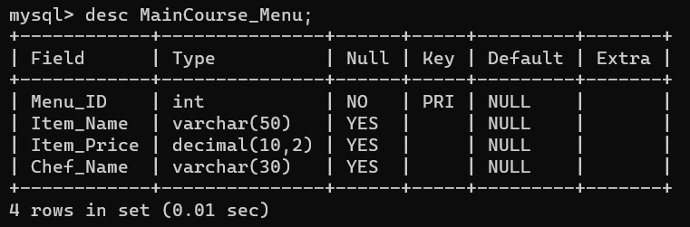

* Dessert_Menu :

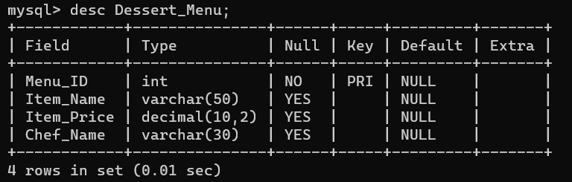

* Orders :

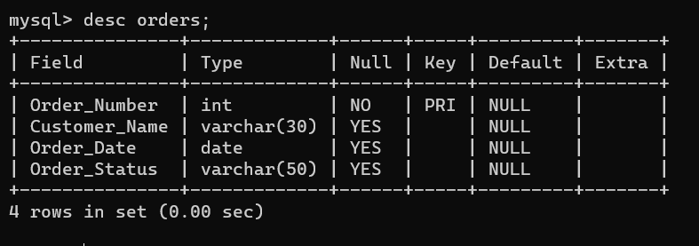

* Payments :

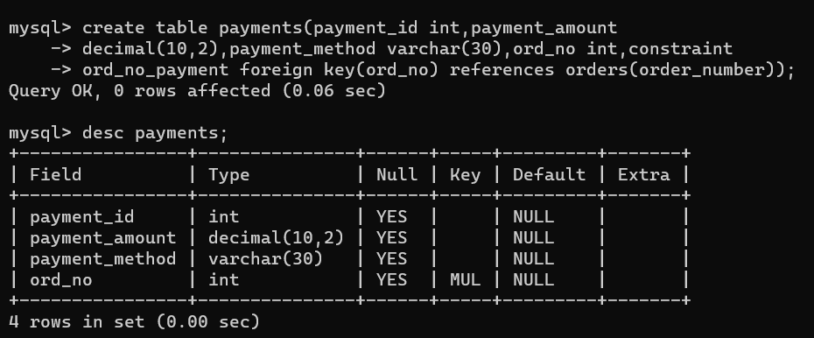

* Customers :

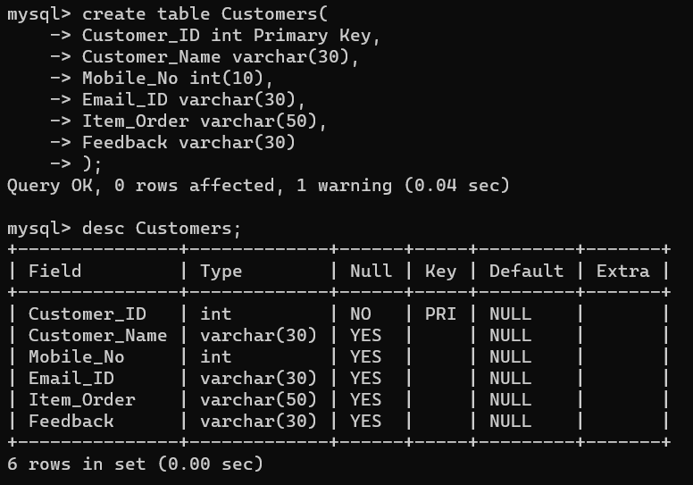

**CONTENT OF TABLE’S**

* Breakfast_Menu :

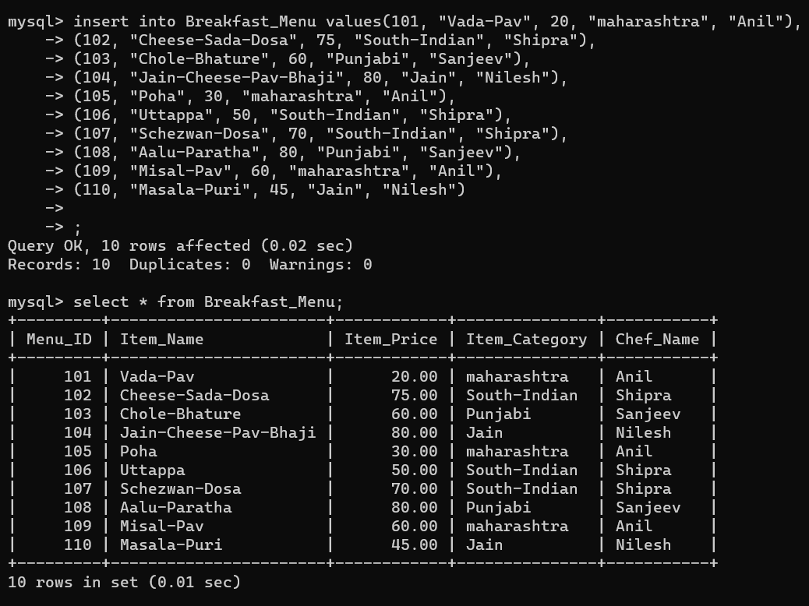

* Starter_Menu :

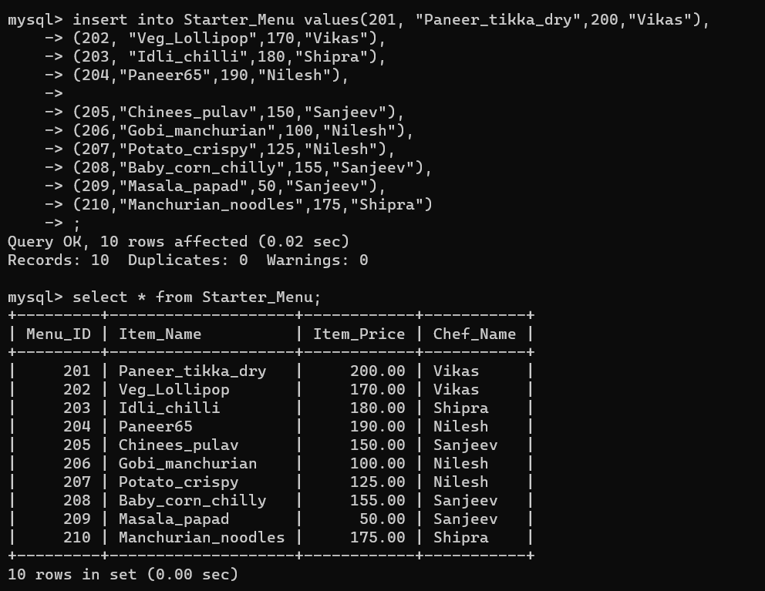

* MainCourse_Menu :

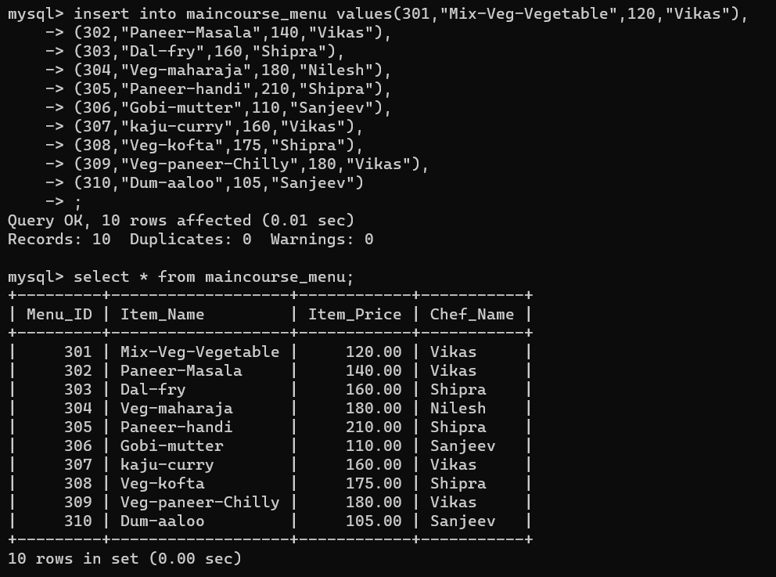

* Dessert_Menu :

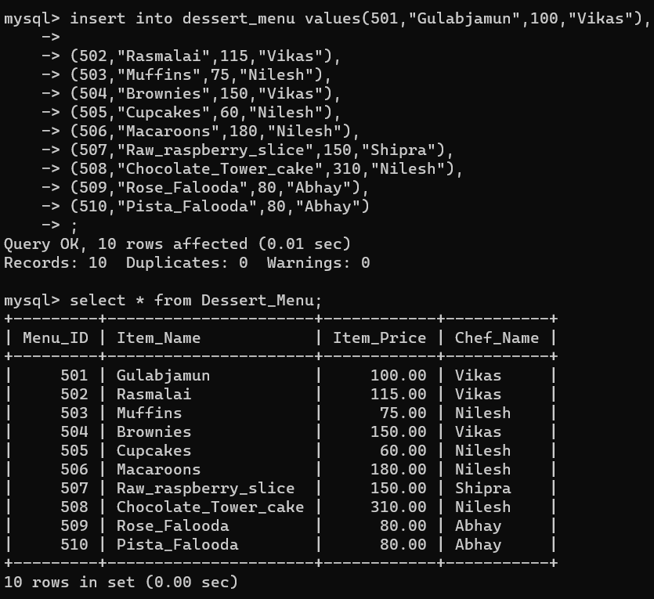

* Orders :

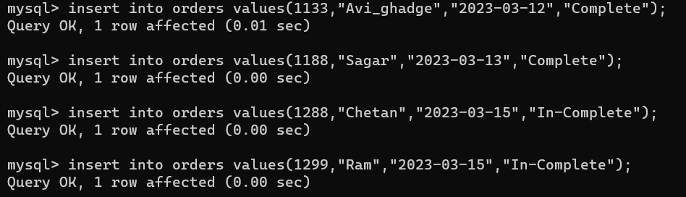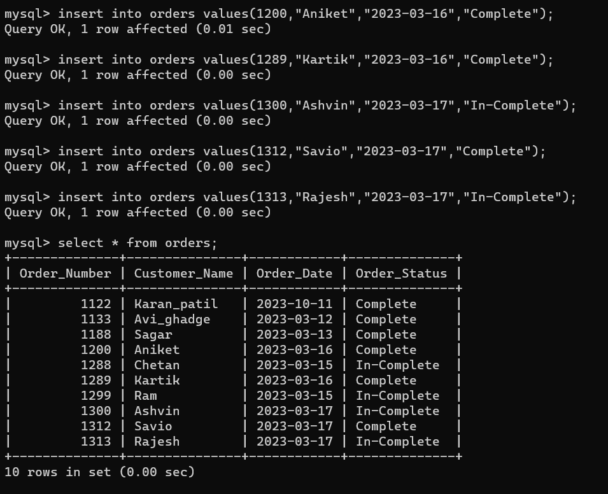

* Payments :

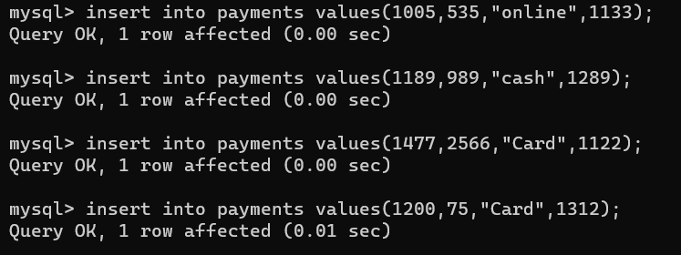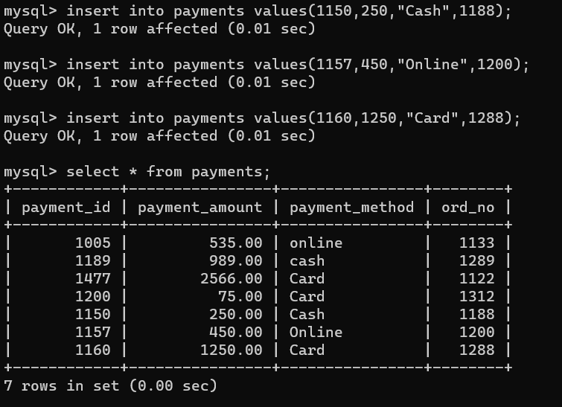

* Customers :

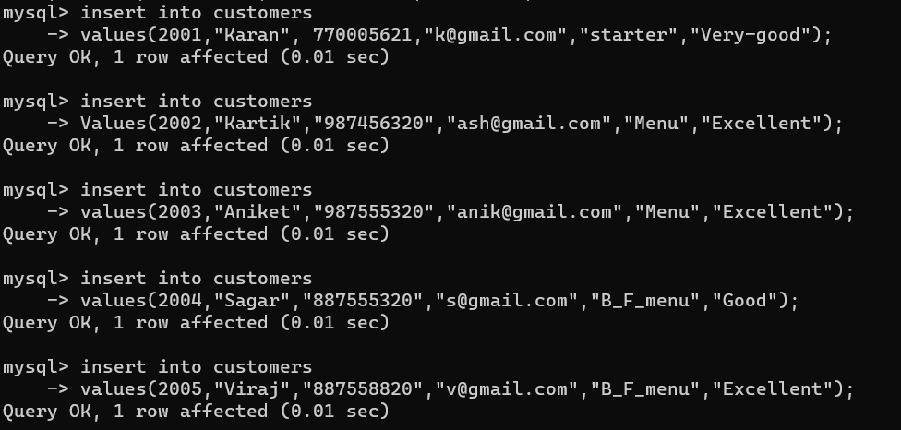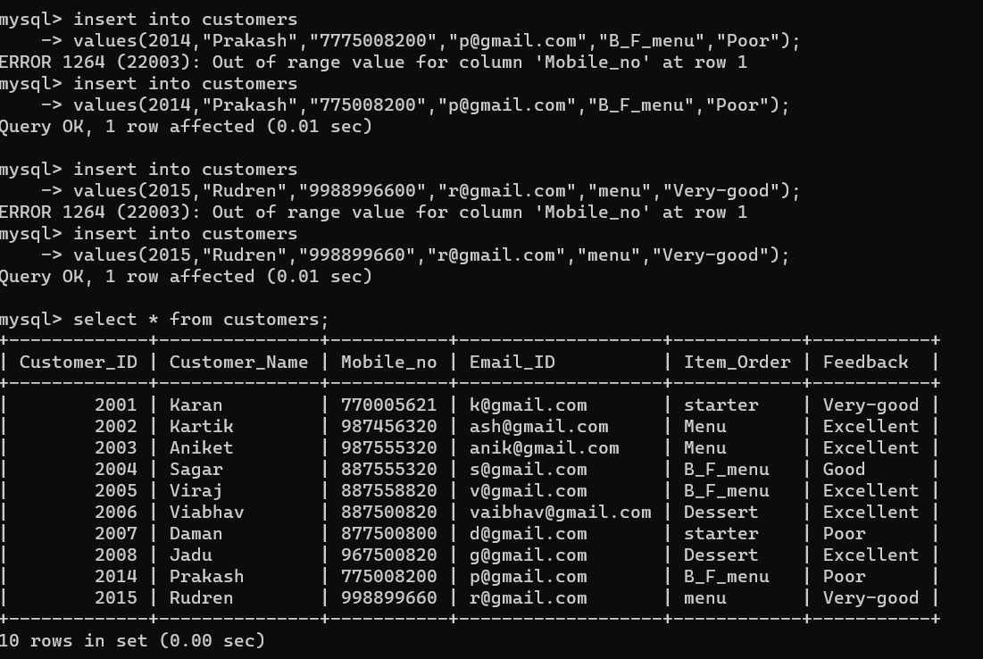

**OPERATOR’S**

* DISPLAY THE FOOD DETAILS FOR BREAKFAST WHICH SHOULD BE SOUTH INDIAN?

**Query:**

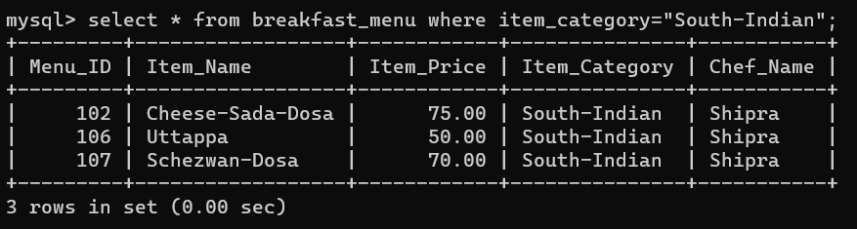

* DISPLAY THE DISCOUNT AMOUNT BY ADDING A DISCOUNT OF 10% ON EACH PAYMENTS?

**Query** :

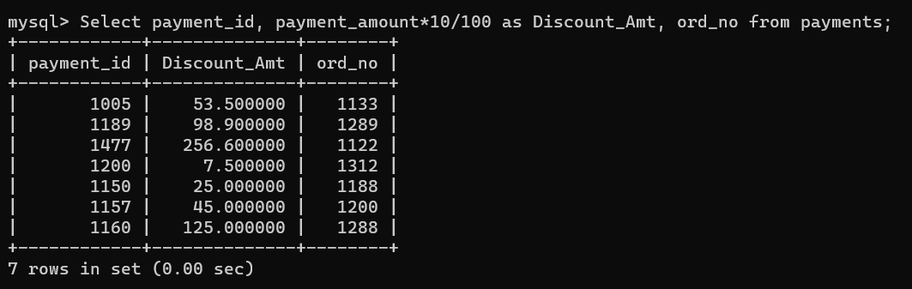

* **COMPARISON :**
* **DISPLAY THE RECORDS OF THE FOOD ITEMS FROM MAIN COURSE AND STARTER HAVING PRICE MORE THAN 100, PRICE LESS THAN 100 & PRICE GREATER THAN EQUAL TO 200.**

**Query:**

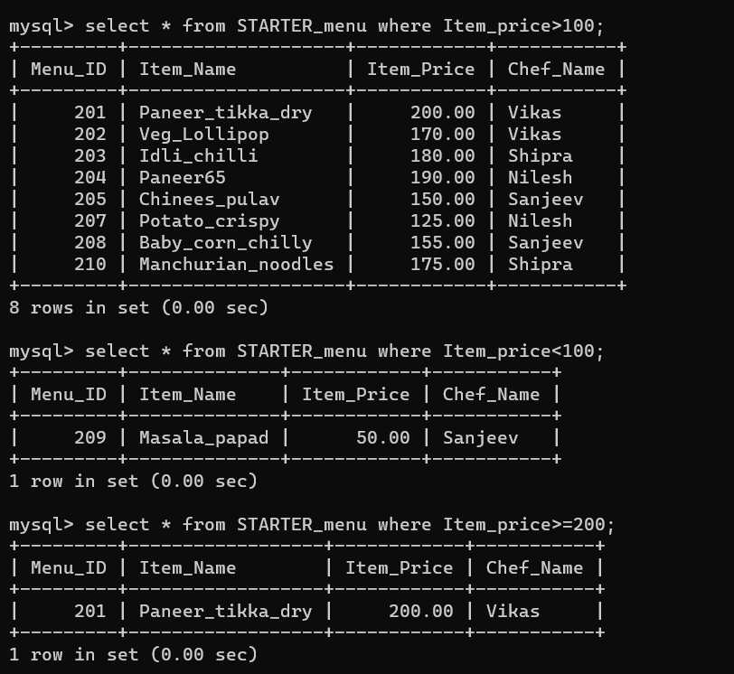

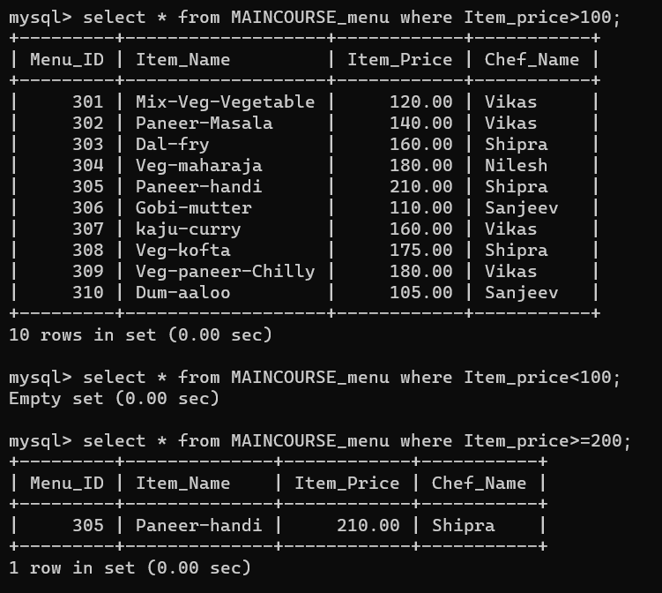

* LOGICAL :
* DISPLAY THE RECORDS OF BREAKFAST DISHES WHICH ARE UNDER 60 AND IT MUST BE MAHARASHTRA DISHES?

**Query:**

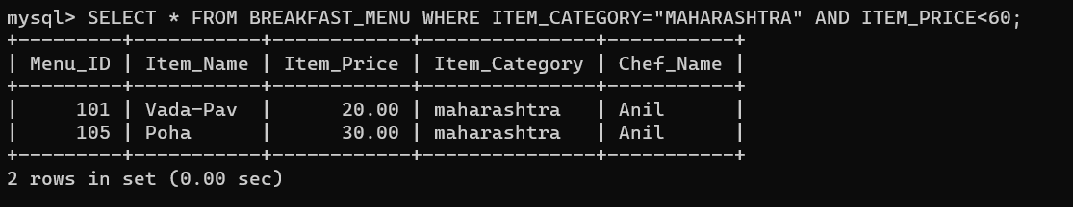

* DISPLAY THE RECORDS OF CUSTOMERS WHO ORDERED MAIN COURSE AND PROVIDED EXCELLENT FEEDBACK?

**Query:**

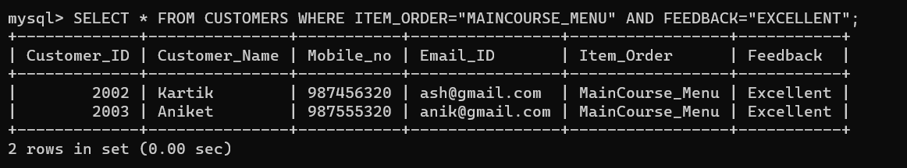

* **RANGE, LIKE, LIST :**
* DISPLAY THE DETAILS OF RECORDS WHICH ARE ORDERED BETWEEN 2023-10-09 TO 2023-10-11?

**Query:**

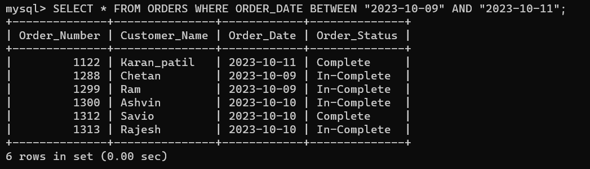

* DISPLAY ALL THE DETAILS OF CUSTOMERS WHO’S CUSTOMERS ID ARE 2001, 2003, 2005, 2007, 2008 & 2015?

**Query:**

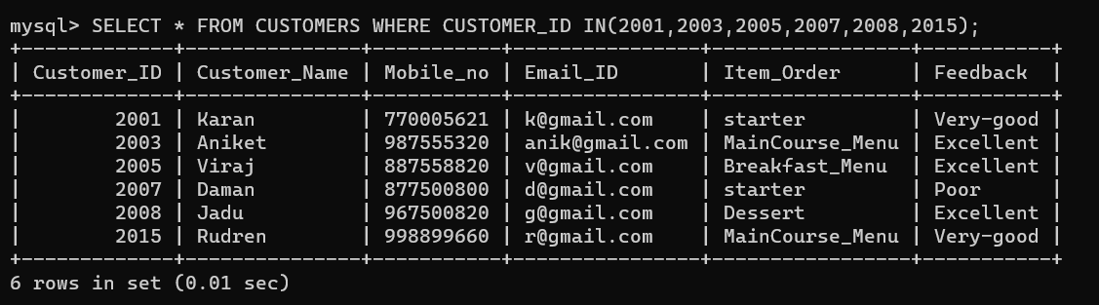

* DISPLAY THE RECORDS OF CUSTOMERS HAVING NAME STARTS WITH ‘V’?

**Query:**

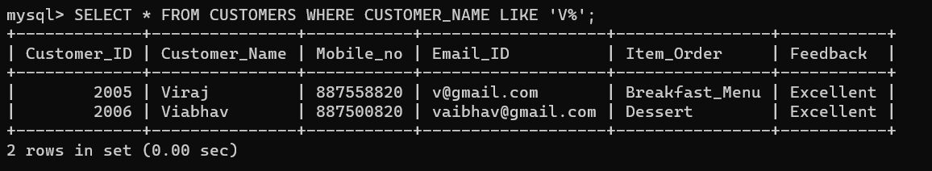

* DISPLAY THE RECORDS FROM DESSERT MENU WHERE ITEM NAMES ARE ENDING WITH LETTER ‘S’?

**Query:**

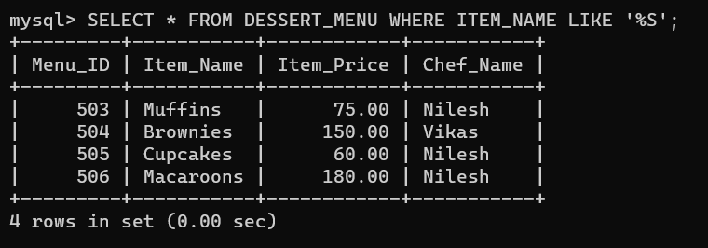

* DISPLAY THE NAME AND ORDER NUMBER OF CUSTOMERS WHO ORDERED THE FOOD ON 2023-10-10?

**Query:**

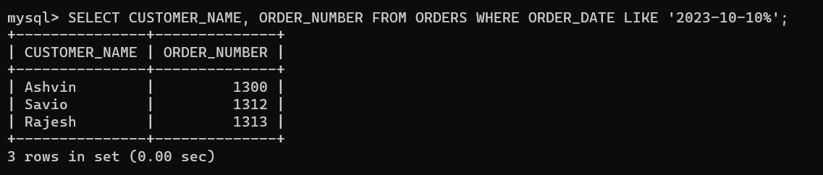

* DISPLAY THE RECORDS OF CUSTOMERS HAVING ‘88’ IN THEIR MOBILE NUMBER?

**Query:**

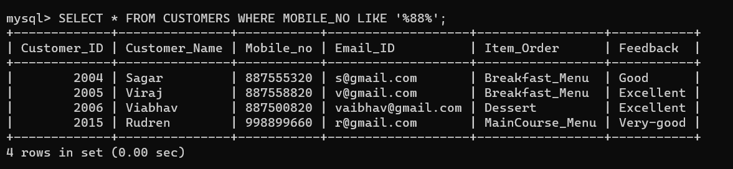

* DISPLAY THE RECORDS WHERE STARTER HAVING A, I, O, IN THEIR NAME?

**Query:**

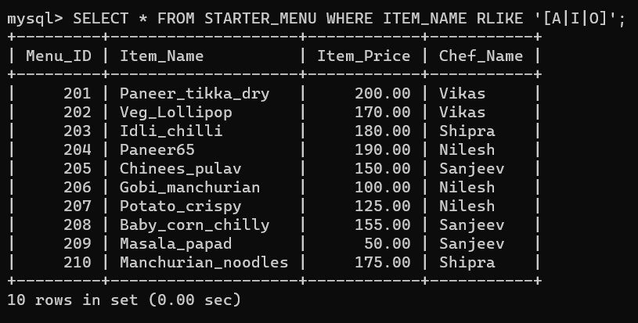

**AGGREGATE FUNCTION’S**

* **MIN** :
* DISPLAY THE RECORD OF MINIMUM ITEM PRICE FROM MAIN COURSE?

**Query:**

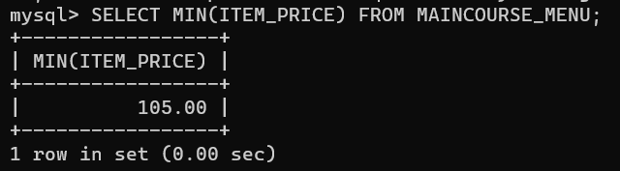

* DISPLAY THE RECORD OF MINIMUM PAYMENT AMOUNT?

**Query:**

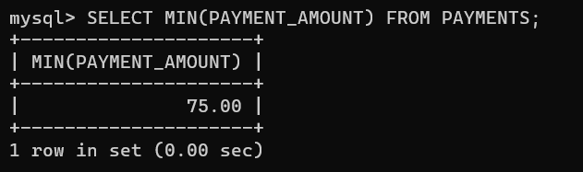

* **MAX :**
* DISPLAY THE RECORD OF MAXIMUM ITEM PRICE FROM BREAKFAST?

**Query:**

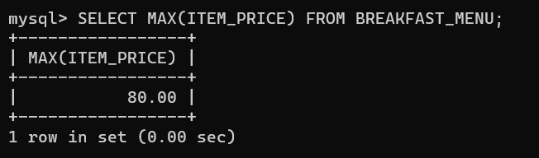

* DISPLAY THE RECORD OF MAXIMUM PAYMENT AMOUNT?

**Query:**

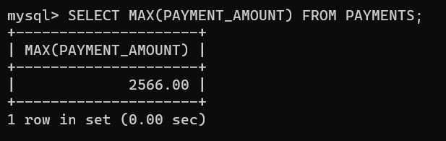

* DISPLAY THE PAYMENT ID, ORDER NO & PAYMENT AMOUNT WHERE PAYMENTS MUST BE GREATER THAN AVERAGE PAYMENT AMOUNT WITH THEIR ORDER NO?

**Query:**

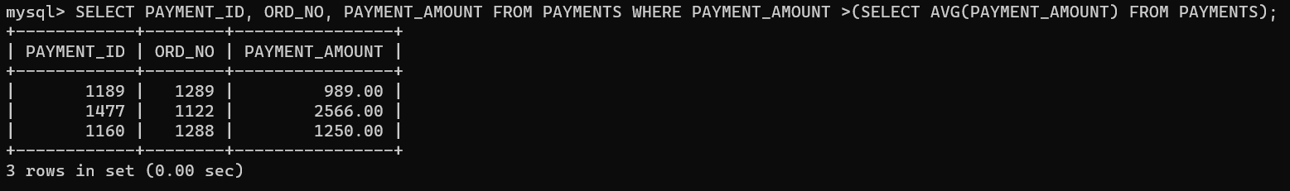

* **COUNT** :
* DISPLAY THE TOTAL COUNT OF DISHES AVAILABLE IN STARTER MENU?

**Query:**

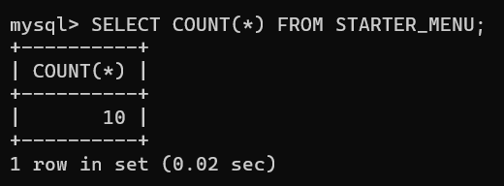

**CLAUSE’S**

* WHERE CLAUSE :
* DISPLAY THE RECORDS OF CUSTOMER ID AND CUSTOMER NAME WHERE CUSTOMER’S FEEDBACK IS SHOWING POOR?

**Query:**

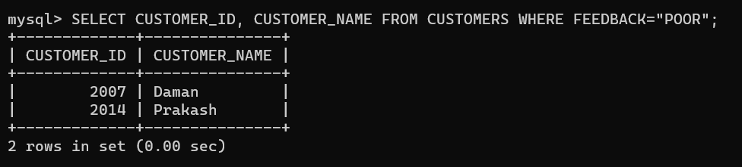

* GROUP BY CLAUSE :
* DISPLAY THE RECORDS OF ORDER STATUS AND CUSTOMER NAME WHERE ORDER STATUS IS COMPLETE?

**Query:**

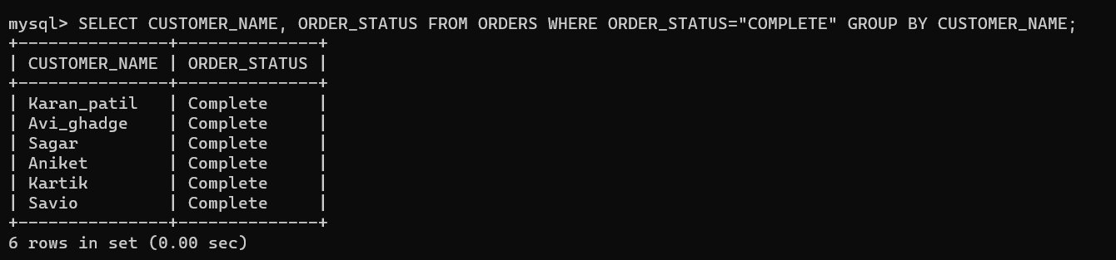

* HAVING CLAUSE :
* DISPLAY THE RECORDS WHERE MINIMUM PAYMENT AMOUNT of PAYMENTS, BELOW 1000 with respect to ORDER NO?

**Query:**

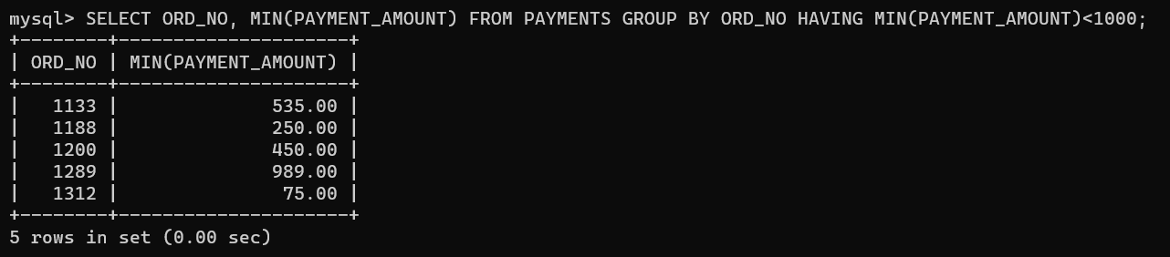

* ORDER BY CLAUSE :
* DISPLAY ALL THE DETAILS OF ORDERS IN ASCENDING ORDER WITH RESPECT TO ORDER_DATE?

**Query:**

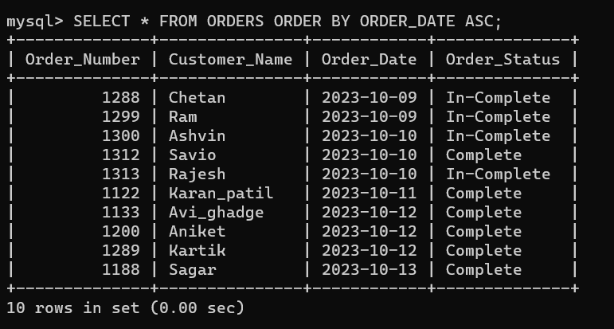

* DISPLAY THE DETAILS OF FOOD ITEMS FROM STARTER WHERE PRICE SHOULD BE IN DESCENDING ORDER?

**Query:**

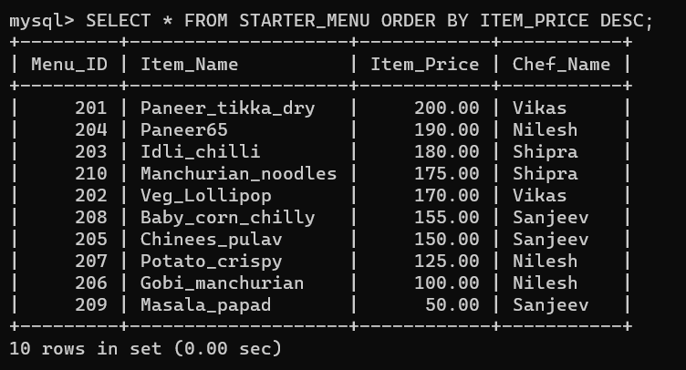

* LIMIT :
* DISPLAY THE RECORDS OF FIRST 5 CUSTOMERS AND WRITE ANOTHER QUERY TO SHOW THE RECORDS OF 7 & 8TH CUSTOMER?

**Query:**

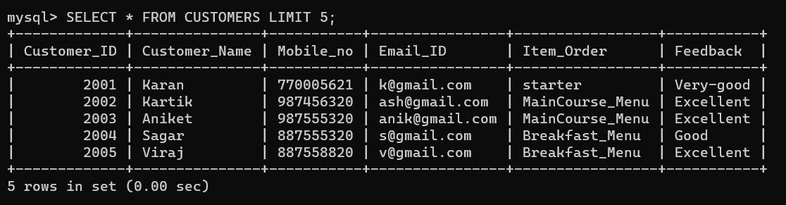

FOR 7 & 8TH CUSTOMER :

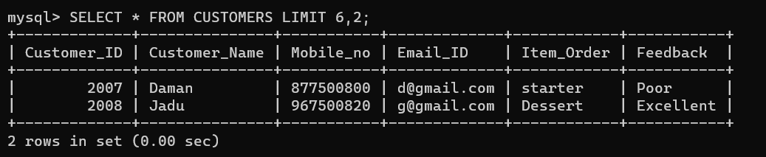

**JOIN’S**

* **INNER JOIN :**
* **DISPLAY THE RECORDS WHERE ORDER DETAILS AND PAYMENT DETAILS MUST BE LISTED IN ONE TABLE.**

**Query:**

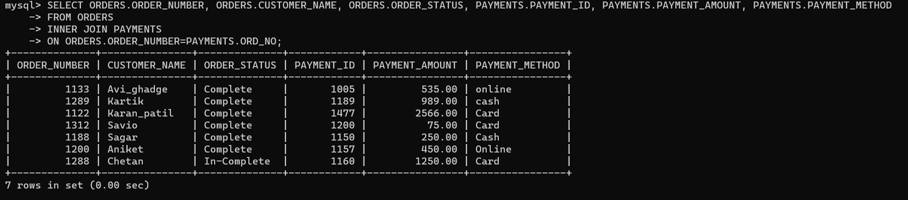

* **LEFT JOIN :**
* **WRITE A QUERY TO LEFT JOIN PAYMENTS TABLE ON ORDERS TABLE.**

**Query:**

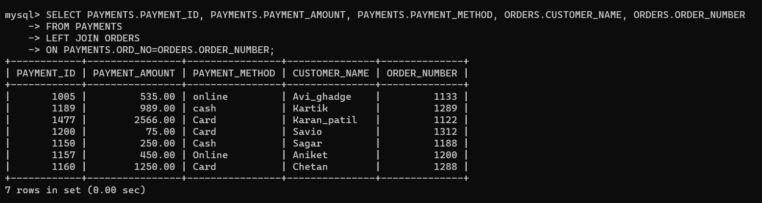

* **RIGHT JOIN :**
* **WRITE A QUERY TO RIGHT JOIN PAYMENTS TABLE ON ORDERS TABLE.**

**Query:**

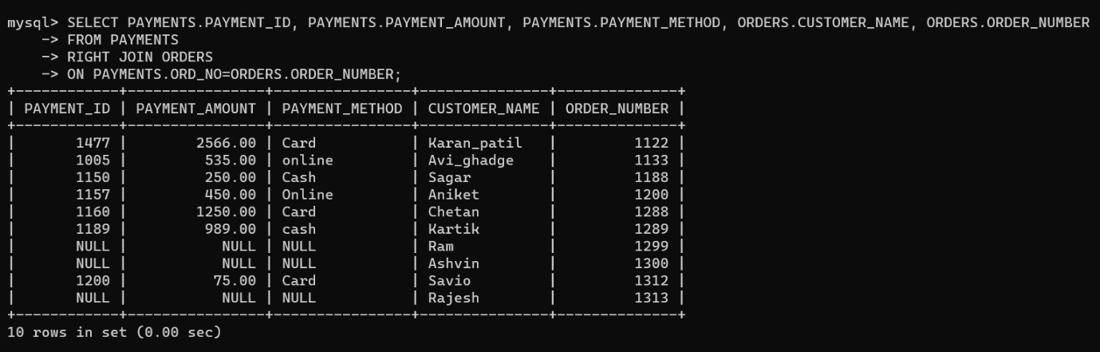

* **CROSS JOIN :**
* **WRITE A QUERY TO SHOW RECORDS OF CROSS JOIN FOR ORDERS TABLE ON PAYMENTS TABLE.**

**Query:**

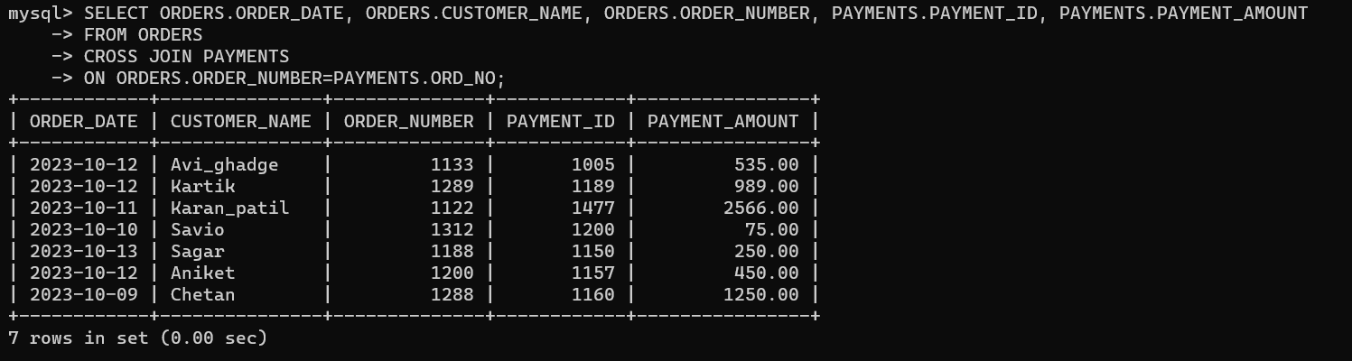

**SUB-QUERIES**

* DISPLAY THE RECORDS OF FOOD ITEMS OF BREAKFAST WHERE ITEM PRICE MUST BE GREATER THAN AVERAGE PRICE?

**Query:**

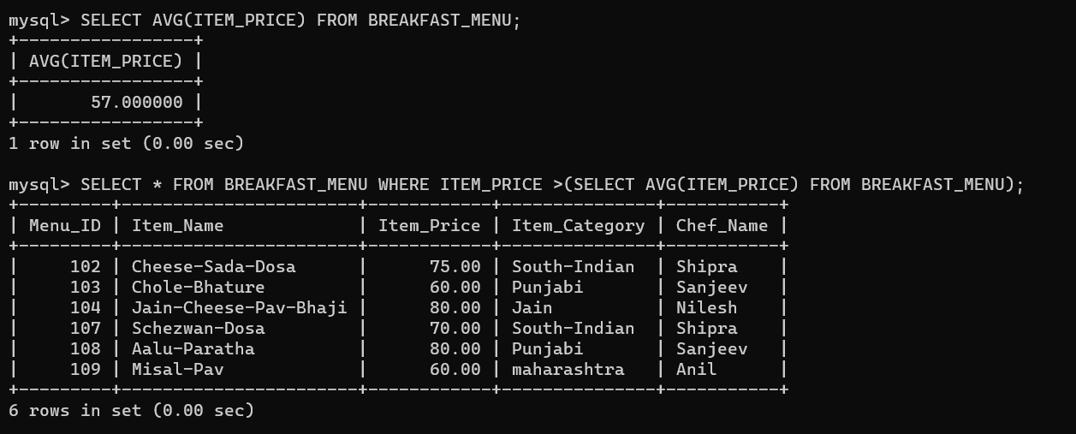

* DISPLAY ALL THE DETAILS FOR 2TH HIGHEST PAYMENT?

**Query:**

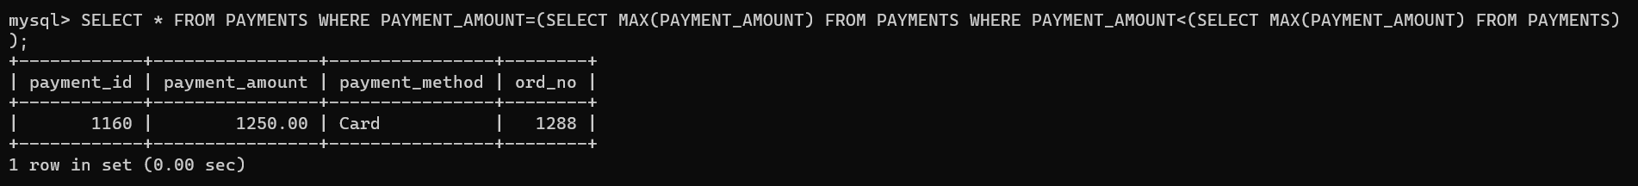

* DISPLAY THE 3RD HIGHEST AMOUNT FOR DISH AVAILABLE IN MAIN COURSE MENU?

**Query:**

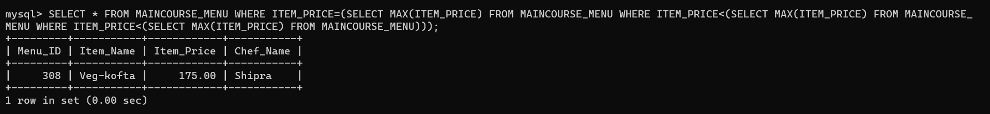

* **ALIAS :**
* DISPLAY THE ORD_NO RECORDS FROM PAYMENTS AS ORDER_NUMBER?

**Query:**

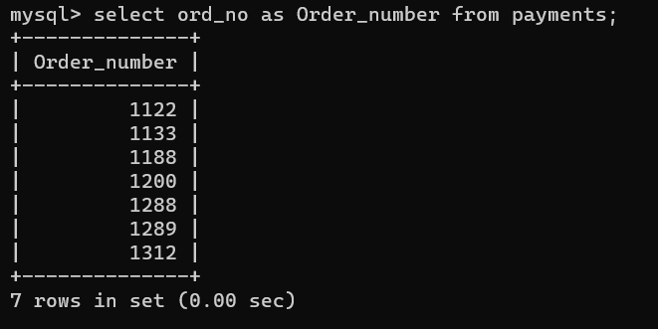

* **VIEW :**
* DISPLAY THE RECORD OF ITEM NAME & PRICE FROM BREAKFAST MENU AND CREATE A VIRTUAL TABLE?

**Query:**

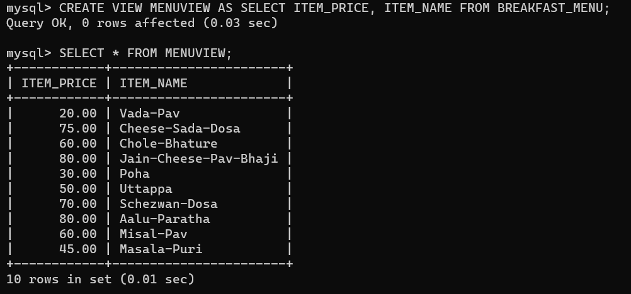

* **ALTER :**
* WRITE A QUERY TO ADD NEW COLUMN IN BREAKFAST TABLE?

**Query:**

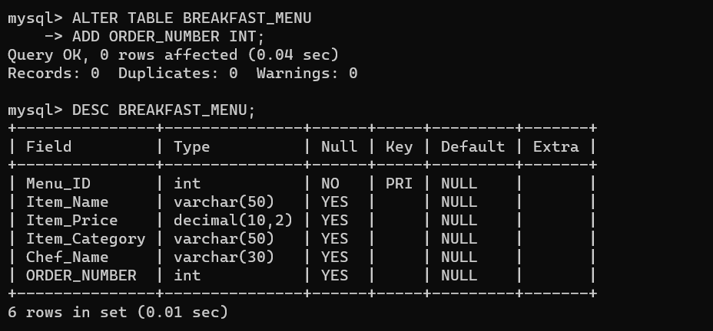

* WRITE A QUERY TO CHANGE COLUMN NAME IN BREAKFAST TABLE?

**Query:**

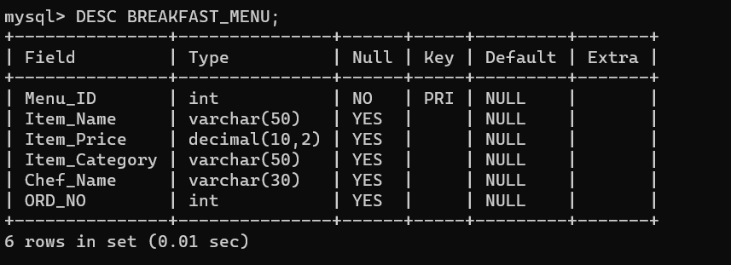

* WRITE A QUERY TO DROP A COLUMN IN BREAKFAST TABLE?

**Query:**

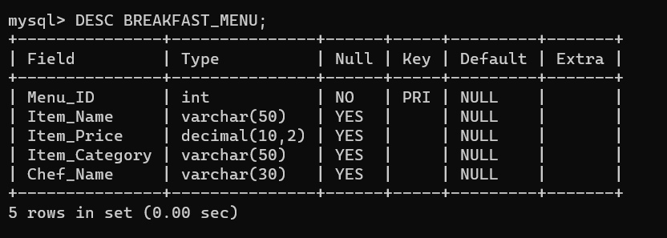

* WRITE A QUERY TO CHANGE ROW DATA FROM POOR TO GOOD IN CUSTOMER’S FEEDBACK?

**Query:**

